**Full Text Search**

Create new ionic project using command **Prompt**- ionic start <project name>

D:\> ionic start FullTextSearch

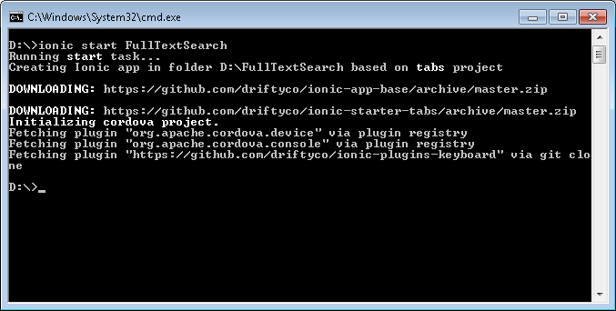

This will create simple project. Now, you can find project folder with following structure.

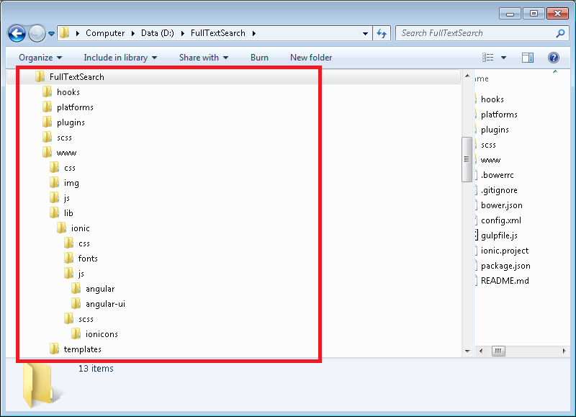

There are following step to develop app with “**full text search**” functionality -

* Create service for **EmployeeService** with two function
* findAll – it will return all employee data.
* findByAllDetail–it will return data as per the search text.

.factory('EmployeeService', function($q) {

//json of employee detail.

var employees = [

{"id": 1, "firstName": "James", "lastName": "King", "title": "President and CEO", "department": "Corporate", "cellPhone": "617-000-0001", "officePhone": "781-000-0001", "email": "jking@fakemail.com", "city": "Boston, MA", "pic": "James_King.jpg"},

{"id": 2, "firstName": "Julie", "lastName": "Taylor", "title": "VP of Marketing", "department": "Marketing", "cellPhone": "617-000-0002", "officePhone": "781-000-0002", "email": "jtaylor@fakemail.com", "city": "Pune, MA", "pic": "Julie_Taylor.jpg"},

{"id": 3, "firstName": "Eugene", "lastName": "Lee", "title": "CFO", "department": "Accounting", "cellPhone": "617-000-0003", "officePhone": "781-000-0003", "email": "elee@fakemail.com", "city": "Mumbai, MA", "pic": "Eugene_Lee.jpg"},

{"id": 4, "firstName": "John", "lastName": "Williams", "title": "VP of Engineering", "department": "Engineering", "cellPhone": "617-000-0004", "officePhone": "781-000-0004", "email": "jwilliams@fakemail.com", "city": "Pune, MA", "pic": "John_Williams.jpg"},

{"id": 5, "firstName": "Pure", "lastName": "Moore", "title": "VP of Sales", "department": "Sales", "cellPhone": "617-000-0005", "officePhone": "781-000-0005", "email": "rmoore@fakemail.com", "city": "Nagpur, MA", "pic": "Ray_Moore.jpg"},

];

return {

findAll: function() {

var deferred = $q.defer();

deferred.resolve(employees);

return deferred.promise;

},

findByAllDetail: function(searchKey) {

var deferred = $q.defer();

var results = employees.filter(function(element) {

var fullName = element.firstName + element.city;

return fullName.toLowerCase().indexOf(searchKey.toLowerCase()) > -1;

});

deferred.resolve(results);

return deferred.promise;

}

};

});

**The above code will search on first Name and city (both).**

* Following are the Template code-

Now add search box on one of the templates as follows:-

<input id="searchKey" type="search" placeholder="Search" ng-model="searchKey" autocorrect="off" ng-change="search()">

* When we type in searchbox it will call search() which is written in the controller-

$scope.search = function() { EmployeeService.findByAllText($scope.searchKey).then(function(employees) {

$scope.count = employees.length;

$scope.employees = employees;

});

};

* For displaying all employee data there is a function “**findAllEmployees**” in controller –

var findAllEmployees = function() {

EmployeeService.findAll().then(function(employees) {

$scope.employees = employees;

});

};

findAllEmployees();

In above code, There is a function findAll(), which is written in service. It is return all employee detail

* Now add clear button right side of search box:-

<button class="button button-assertive" ng-click="clearSearch()">Clear</button>

* When we click on clear it will call clearSearch() function which is written in controller-

$scope.clearSearch = function() {

$scope.searchKey = "";

$scope.count =1;

findAllEmployees();

};

After all the changes, Application is ready to run on device. Following are the screen short of App-

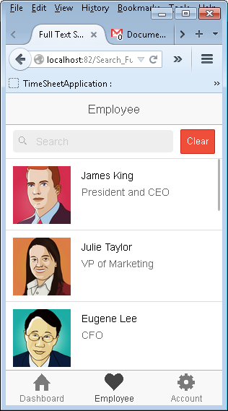 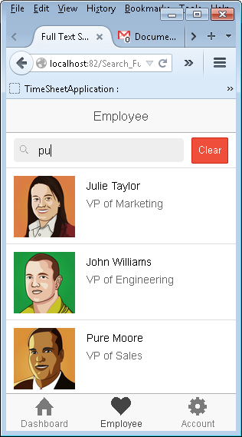

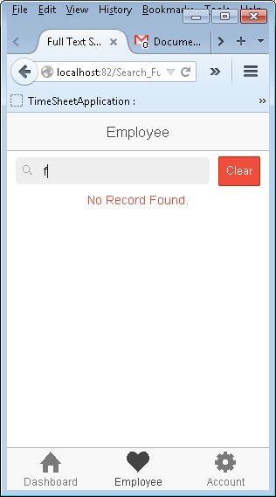

**Important Link –**

* <https://github.com/shashikantkumar88/Full-Text-Search>
* <https://github.com/ccoenraets/directory-angular-ionic>